**Entry Form**

**Please fill out and email it to us before the 1st of November 2023 together with pictures of the group**

| Name of the group |  |
| --- | --- |
| Contact/ chairman |  |
| Address |  |
| Country |  |
| Phone |  |
| Email |  |
| Website |  |
| Link to a video |  |

Expected:

| Number of dancers |  | Number of musicians |  |
| --- | --- | --- | --- |
| Number of other participants |  | Total number of participants |  |
| Age of the participants |  |  |  |

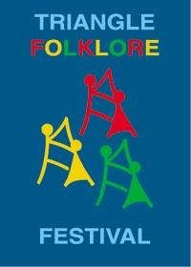

**Triangle Folklore Festival**

**Group contacts Line Guldbrand & Mathilde Smidt**

**E-mail:** [groups@trianglefolklorefestival.dk](mailto:groups@trianglefolklorefestival.dk)

**Webpage:** <http://www.trianglefolklorefestival.dk/>